Stride WMS
Client Onboarding Guide
_______________________________________________
Version 1.3.2 | March 2026
For System Administrators

1. Overview
Client onboarding is the process of setting up a new client in the Stride WMS system. The onboarding automation:
- Creates a Google Drive folder structure for the client
- Copies the Client Inventory Template as a new spreadsheet
- Configures all settings (billing, notifications, storage terms)
- Links the client to the Consolidated Billing system
All onboarding is managed from the Clients tab in the Consolidated Billing spreadsheet.
2. Prerequisites
Before onboarding your first client, verify these are configured:
2.1 Client Inventory Template ID
Row 1 of the Clients tab must contain the Template spreadsheet ID.
- This is the master template that gets copied for each new client
- It should have all tabs pre-configured (Inventory, Tasks, Repairs, etc.)
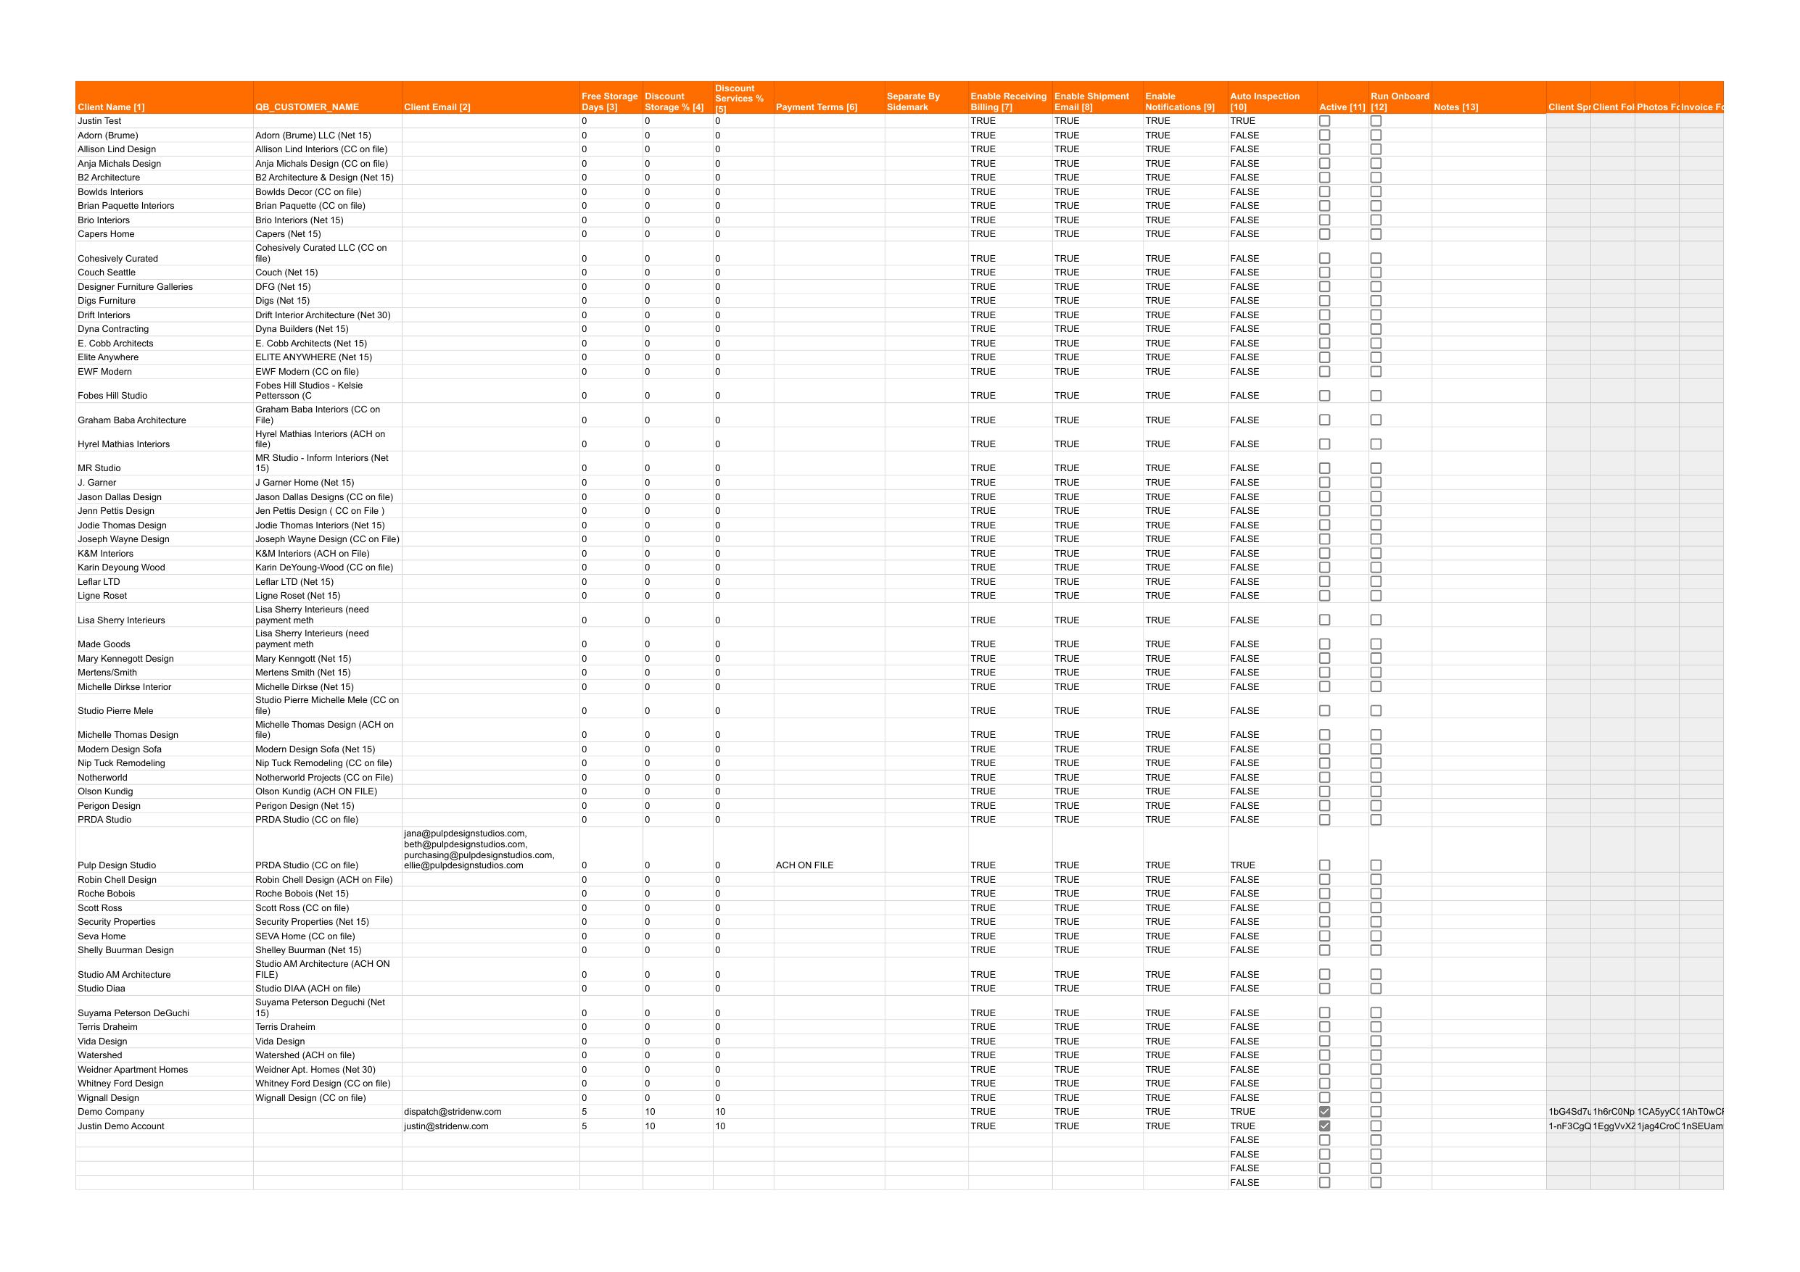
2.2 Client Parent Folder ID
Row 2 of the Clients tab must contain the Google Drive folder ID.
- This is the parent folder where all client folders will be created
- Each new client gets a subfolder inside this folder

2.3 QB_Service_Mapping
The QB_Service_Mapping tab must be filled out with your service codes:
Svc Code | Svc Name | QB Income Account | Default Payment Terms | QB Item Name
RCVG | Receiving | Warehouse Revenue | Net 30 | Receiving
INSP | Inspection | Warehouse Revenue | Net 30 | Inspection
STOR | Storage | Storage Revenue | Net 30 | Storage
REPAIR | Repair | Repair Revenue | Net 30 | Repair
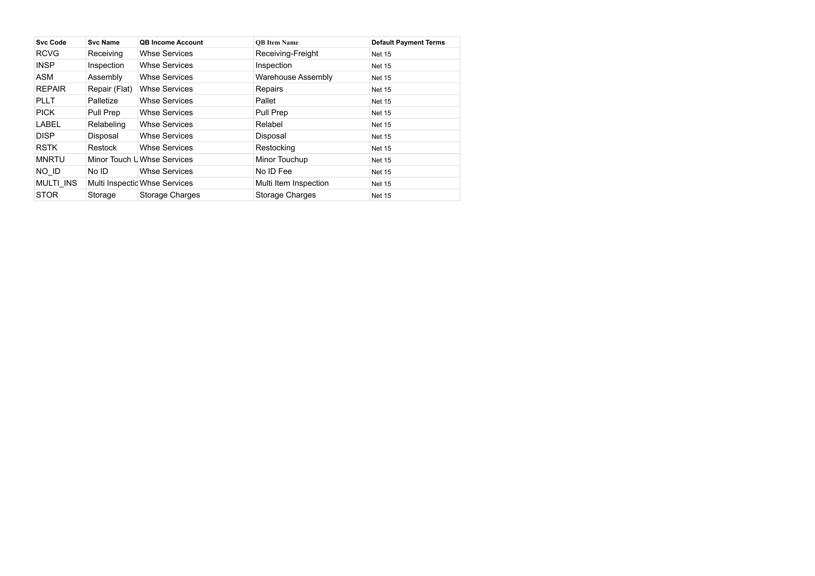
3. Adding a New Client
3.1 Step-by-Step
- Open the Consolidated Billing spreadsheet
- Click the Clients tab
- Scroll down to the first empty data row (row 5 or below)

- Fill in the following columns:
Column | Required? | Description | Example
Client Name | Yes | Display name for the client | Acme Design Co
Client Email | Recommended | Billing/contact email | billing@acme.com
Free Storage Days | No | Days before storage charges begin (default: 0) | 30
Discount Storage % | No | Storage discount percentage | 10
Discount Services % | No | Services discount percentage | 0
Payment Terms | Recommended | Invoice payment terms | Net 30
Separate By Sidemark | No | TRUE if invoices should be split by sidemark | TRUE
Enable Receiving Billing | No | TRUE to auto-bill receiving (default: TRUE) | TRUE
Enable Shipment Email | No | TRUE to send shipment emails (default: TRUE) | TRUE
Enable Notifications | No | TRUE for all notifications (default: TRUE) | TRUE
Auto Inspection | No | TRUE to auto-create inspections (default: TRUE) | TRUE
QB Customer Name | No | QuickBooks customer name if different | Acme Design

- Check the "Run Onboard" checkbox in the last column

- Wait for the automation to complete (a toast notification will appear)
3.2 What Happens Automatically
When you check "Run Onboard", the system:
- Creates a client folder in Google Drive (under the Parent Folder)
- Creates a "Photos" subfolder inside the client folder
- Creates an "Invoices" subfolder inside the client folder
- Copies the Client Inventory Template and names it after the client
- Writes all settings to the new client's Settings tab:
  - CLIENT_NAME, CLIENT_EMAIL
  - FREE_STORAGE_DAYS, PAYMENT_TERMS
  - DISCOUNT_STORAGE_PCT, DISCOUNT_SERVICES_PCT
  - SEPARATE_BY_SIDEMARK
  - All notification and billing toggles
  - Drive folder IDs, Consolidated Billing spreadsheet ID
- Writes the new spreadsheet ID, folder IDs back to the Clients tab
- Sets Active = TRUE
- Unchecks "Run Onboard"
3.3 After Onboarding
After the automation completes:
- Open the new client spreadsheet (link is in the "Client Spreadsheet ID" column)
- Verify the Settings tab has all values populated
- Run Stride Admin → Install Triggers
- Run Stride Admin → Refresh Price/Class Cache
- The client is now ready to receive shipments
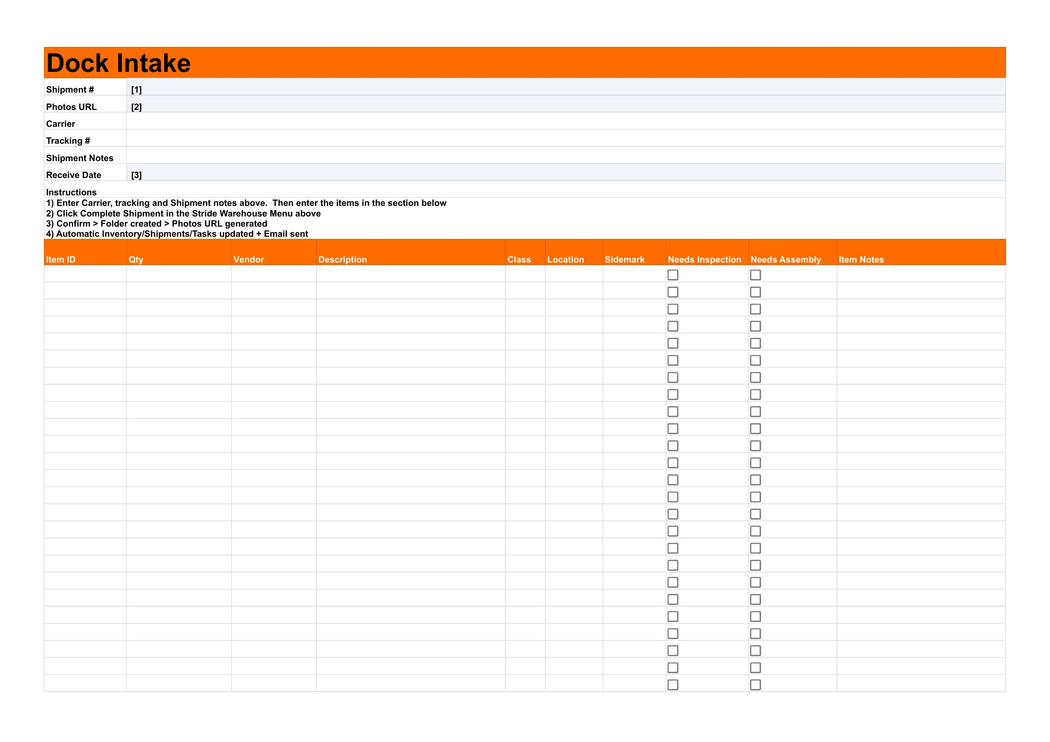
4. Syncing Settings to Existing Clients
When you need to update a client's settings (email change, discount change, payment terms, etc.):
- Open the Consolidated Billing spreadsheet
- Go to the Clients tab
- Edit the values you want to change in the client's row
- Click on any cell in that client's row (so it's selected)
- Click Stride Billing → Sync Settings to Client
- Confirm the sync when prompted
- The updated values are pushed to the client's Settings tab
Important: The sync will create any missing settings keys automatically. This means if a client was onboarded before a new setting was added (like SEPARATE_BY_SIDEMARK), the sync will add it.
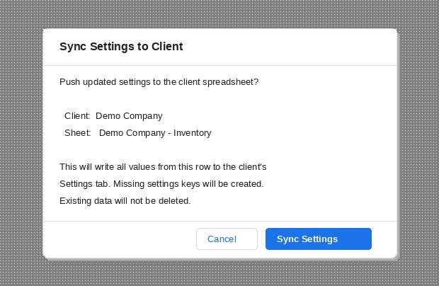
5. Updating Client Scripts
When a new version of the scripts is released:
- Download or copy the updated script files
- Open the client spreadsheet
- Click Extensions → Apps Script
- For each script file:
  - Click on the file name in the left sidebar
  - Select all text (Ctrl+A)
  - Paste the new script (Ctrl+V)
  - Save (Ctrl+S)
- Close the Apps Script editor
- Reload the spreadsheet
- Click Stride Admin → Update Headers & Validations
This safely adds any new columns, fixes dropdowns, and adds missing settings without affecting existing data.
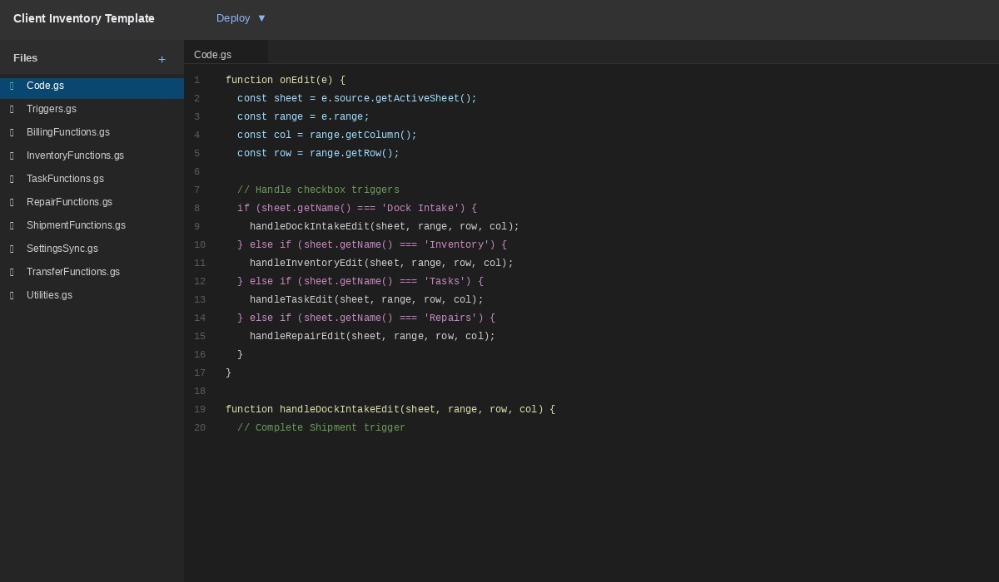
6. Client Settings Reference
Key | Type | Default | Description
OWNER_EMAIL | Email | Auto-detected | Script owner's email
CLIENT_NAME | Text | From Clients tab | Client display name
CLIENT_EMAIL | Email | From Clients tab | Client billing email
FREE_STORAGE_DAYS | Number | 0 | Free days before storage billing starts
PAYMENT_TERMS | Text | Autopay - Card on File | Invoice payment terms
DISCOUNT_STORAGE_PCT | Number | 0 | Storage discount (0-100)
DISCOUNT_SERVICES_PCT | Number | 0 | Services discount (0-100)
SEPARATE_BY_SIDEMARK | TRUE/FALSE | FALSE | Split invoices by sidemark
QB_CUSTOMER_NAME | Text | Blank | QuickBooks customer name override
ENABLE_RECEIVING_BILLING | TRUE/FALSE | TRUE | Auto-create receiving billing rows
ENABLE_SHIPMENT_EMAIL | TRUE/FALSE | TRUE | Send shipment confirmation emails
ENABLE_NOTIFICATIONS | TRUE/FALSE | TRUE | Master notification toggle
AUTO_INSPECTION | TRUE/FALSE | FALSE | Auto-create inspection tasks on intake
MASTER_SPREADSHEET_ID | ID | From setup | Master Price List spreadsheet ID
MASTER_RPC_URL | URL | From setup | Server endpoint for shipment IDs
MASTER_RPC_TOKEN | Token | From setup | Authentication token (do not share)
DRIVE_PARENT_FOLDER_ID | ID | Auto-filled | Client's Google Drive folder ID
PHOTOS_FOLDER_ID | ID | Auto-filled | Photos subfolder ID
CONSOLIDATED_BILLING_SPREADSHEET_ID | ID | Auto-filled | Billing spreadsheet link
7. Clients Tab Column Reference
Column | Auto-Filled? | Description
Client Name | No — you enter | Client display name
Client Spreadsheet ID | Yes | Google Sheets ID of client inventory
Client Folder ID | Yes | Google Drive folder ID
Photos Folder ID | Yes | Photos subfolder ID
Invoice Folder ID | Yes | Invoices subfolder ID
Client Email | No — you enter | Billing contact email
Free Storage Days | No — you enter | Free storage period
Discount Storage % | No — you enter | Storage discount
Discount Services % | No — you enter | Services discount
Payment Terms | No — you enter | Payment terms (dropdown)
Enable Receiving Billing | No — you enter | Auto-bill receiving
Enable Shipment Email | No — you enter | Send shipment emails
Enable Notifications | No — you enter | Notification master toggle
Auto Inspection | No — you enter | Auto-create inspections
Separate By Sidemark | No — you enter | Split invoices by sidemark
Active | Yes (set to TRUE) | Include in billing/task board
Run Onboard | No — you check | Triggers onboarding automation
Notes | No — you enter | Internal notes
QB Customer Name | No — you enter | QuickBooks customer name override

